|  |  |  |  |
| --- | --- | --- | --- |
| **IMAT3904 Report Template**  Please write in the boxes below. Expand the boxes as you need to, however this report should not exceed 2 pages (not including test case data) | | | |
| Name: | Emmanuel Immanuel | P Number: | 2592236 |
| Github Username: | Uzo01 | Github Repo URI: | [IMAT3904/individual-coursework-2022-Uzo01: individual-coursework-2022-Uzo01 created by GitHub Classroom](https://github.com/IMAT3904/individual-coursework-2022-Uzo01) |
| **Please summarise the functionality of your game engine (bullet points are fine):** | | | |
| * Render 3D shapes * Uses OOP to break down code * Camera functionality * Run Multiple tests * DOxygen report on each line of code * Keyboard implementation * Mouse Implementation | | | |
| **What testing have you performed and what testing strategy was used? (test cases on next page please)** | | | |
| Performed both event and unit test.  Event test- function that were tested were the size of width of window that event is window resize.  Window close and focus were tested to see if the functions were working, we get the category that is being tested, e.g., getStaticType through EventType and then call the EXPECT function, | | | |
| **Did you change any code as a result of use a profiler or a GPU debugger, if so how?** | | | |
| I had used RenderDoc to debug the GPU I had to first solve the issue which was in the glsl for the flatcolour and the texturedPhong this would not allow us to continue with the debugging. | | | |
| **How have you approached your time management for this piece of work?** | | | |
| I made sure to get the necessary parts done that is need for the engine to work this included adding in the making of the events openGL adding the shader code, this took up the majority of my time due to the fact that I was struggling to implement the code. After adding the main parts I cleaned up the code creating vertex classes to out the shader code from the application.cpp, this left me little time to add the camera and do test for the events and the openGL code. | | | |
| **What have your learned from whilst building your game engine what would you do differently next time?** | | | |
| Do more research on building a game engine rewatch lecture video to understand the theology behind the code. Then add the necessary code need to build the game engine including the cameras and controller with mouse input. I would then clean up the code creating classes for vao, vbo removing them from the application.cpp and do test for each function. | | | |

Appendix:

**TEST CASE DATA**

**Test for the close of the window**

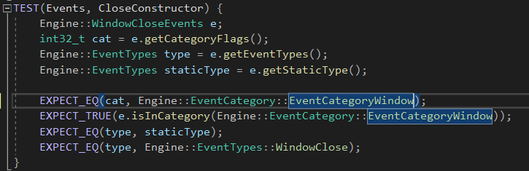

**Test the window focus**

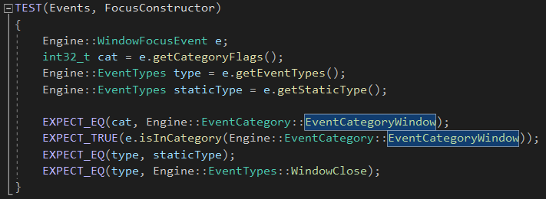

**Window resize test**

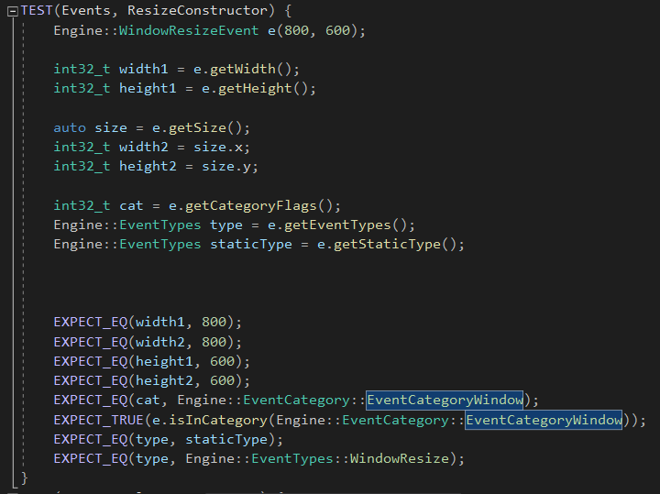

**Test VertexArray constructor**

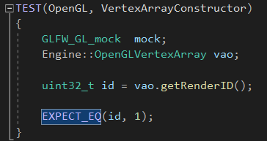

**VertexArrayBUfferNULL test**

